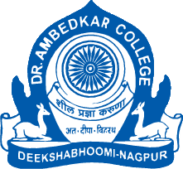
Parampoojya Dr. Babasaheb Smarak Samiti’s
Dr. Ambedkar College, Deekshabhoomi, Nagpur
Webinar on
“Constitutionalism and Pluralism”
Organized by
DEPARTMENT OF LAW
20th December, 2022
NOTICE

Report:
Dr. Ambedkar College, Department of Law, Deekshabhoomi, Nagpur, through the Centre for Constitutional Law and Public Policy Debate organized a Webinar by online mode on the topic “Constitutionalism and Pluralism”. The Speaker of the program was Dr. Dilip Ukey, Vice-Chancellor, Maharashtra National Law University, Mumbai. The program was conducted by Mr. Atik Pansare, Student of LL.B. at Dr. Ambedkar College, Deekshabhoomi, Nagpur. The program commenced with a welcome address by Dr. H.V. Menon, Professor & Head, Department of Law, Dr. Ambedkar College, Deekshabhoomi, Nagpur where an insight was given about the importance of Constitutionalism and its interrelationship with Pluralism.

The speaker introduced the concept by highlighting its function of limiting the powers of the Government and stated that the concept of Constitutionalism emanates from the Constitution itself. He also explained the origin of the concept of Constitutionalism by tracing the development of the theory of Natural Law and Natural Rights.
He stated that it is not only the Constitution which imposes a limitation on the powers of the Government but also the judiciary plays an important role. The Speaker also discussed important cases such as Dr. Bonham’s Case 1610, Marbury V. Madison 1803, Maneka Gandhi V. Union of India,1978 to give a deeper understanding of the concept.
He discussed the 8 fold principles of Constitutionalism given by Louis Henkin as well as the different types of Constitutionalism such as Liberal, Illiberal, Mixed, Revolutionary, Theocratic etc.
The Speaker also deliberated on the concept of Pluralism and its relation to Constitutionalism and highlighted the importance of Transformative Constitutionalism which empowers the state to bring about social transformation. He also discussed the transformative nature of Indian Constitution by giving various examples such as the Fundamental Rights, Directive Principles of State Policy, Fundamental Duties etc. The speaker also highlighted the important role of the judiciary in bringing about transformation in cases such as Navtej Singh Johar and K.S. Puttaswamy.
The lecture was then followed by Question – Answer Session.
The Guest lecture was attended by approximately 100 participants comprising of the students from LL.B and LL.M. of the Department of Law and the faculty members of the Department of Law, Ms. Shazia Bari , Assistant Professor, Department of Law, Dr. Ambedkar College, Deekshabhoomi, Nagpur, Ms. Anusha Patre , Assistant Professor, Department of Law, Dr. Ambedkar College, Deekshabhoomi, Nagpur, Ms. Aishwarya Peshwe , Assistant Professor, Department of Law, Dr. Ambedkar College, Deekshabhoomi, Nagpur. The feedback was also taken from the students.

Photos:
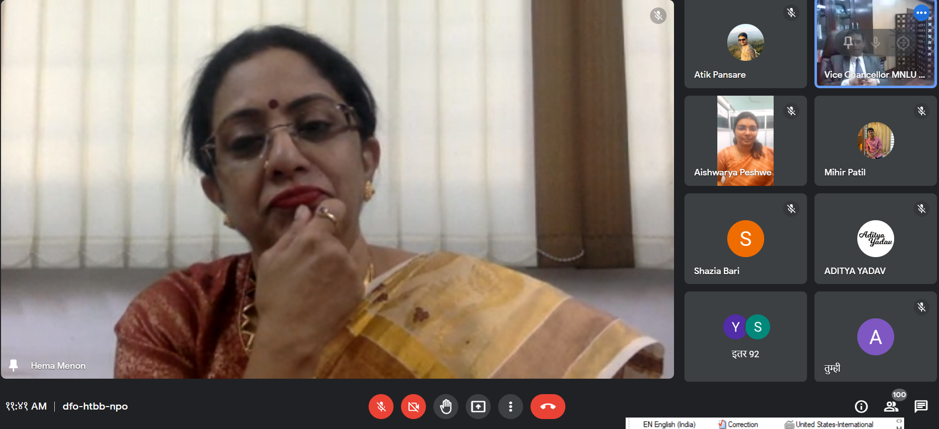
Dr. H.V. Menon, Professor & Head, Department of Law, Dr. Ambedkar College, Deekshabhoomi, Nagpur delivering the Welcome Address in the Webinar on “Constitutionalism and Pluralism”.

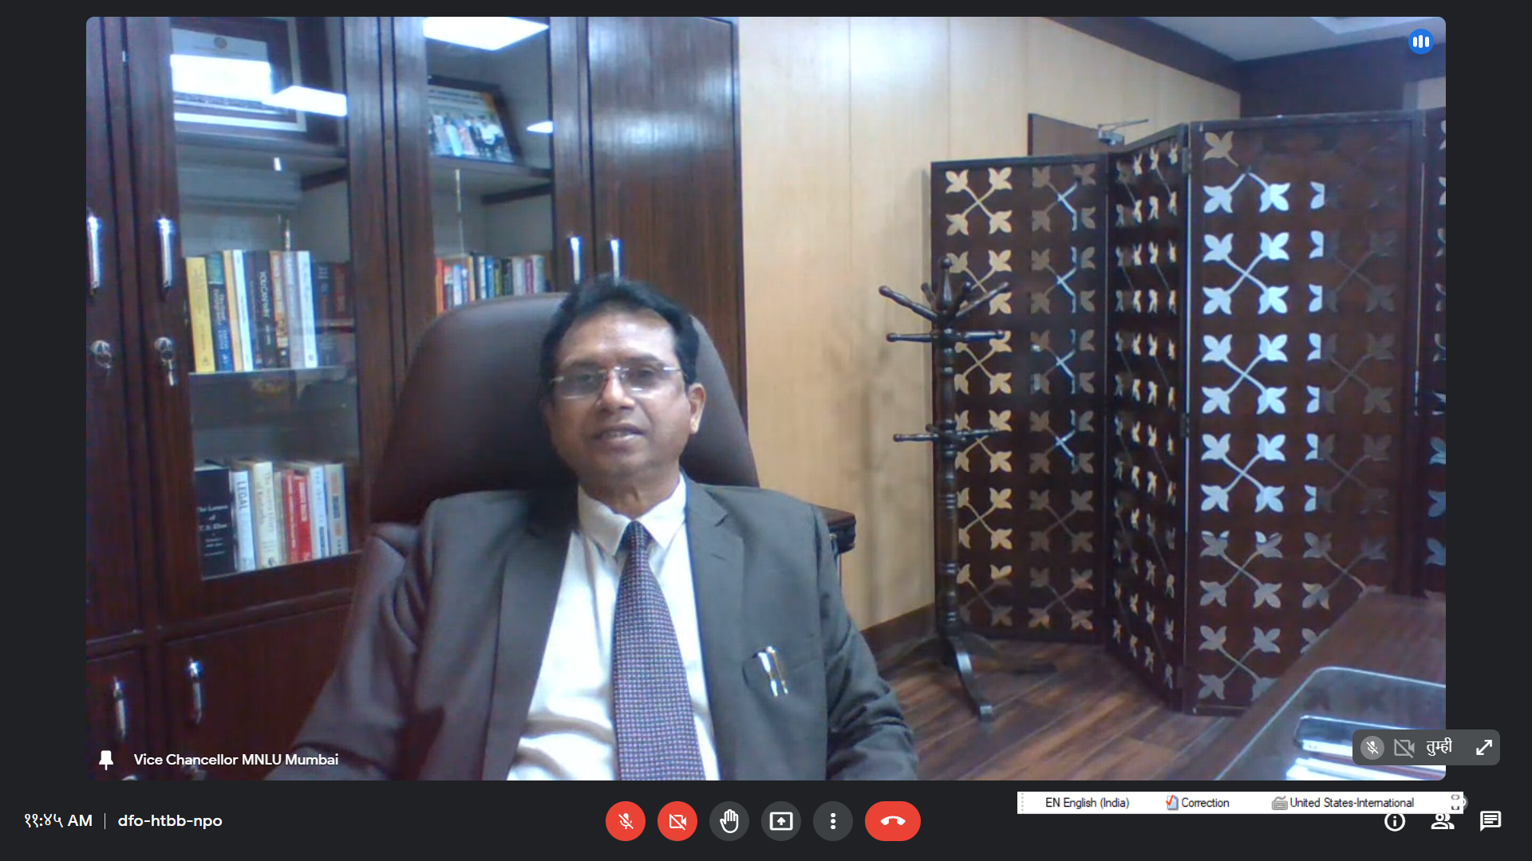
Dr. Dilip Ukey, Vice Chancellor, MNLU, Mumbai delivering the lecture on “Constitutionalism and Pluralism.
Feedback forms of the Students are attached below: 